SOP: Connecting to SnapLogic and Creating Pipelines (Detailed Guide)

Document Version History 3
1. Purpose & Scope 4
2. Logging In to SnapLogic 4
3. SnapLogic Interface Overview 5
3.1 Designer 5
3.2 Manager 5
3.3 Monitor 5
4. Snaps, Pipelines, and Patterns 6
4.1 Snaps 6
4.2 Pipelines 6
4.3 Patterns 7
5. Pipeline Setup 8
5.1. Preparing the Project Structure 8
5.2 Creating a Pipeline 9
6. Building the Pipeline – Detailed Steps 12
7. Demo Pipeline creation 13
7.1 HTTP Client (POST) – Generate Token 13
7.2 Mapper Snap – Extract and Store Token 15
7.4 JSON Splitter – Extract User Records 17
7.5 Mapper – Map Required Columns 18
7.6 SQL Server Insert – Load Into Ingest 21
7.7 Validating & Executing the Pipeline 23
7.8 Database Validation 25
8. Scheduling the Pipeline (Task Creation) — Detailed SOP Section 25
8.1 Navigate to Tasks 26
8.2 Create a new Pipeline Task 26
8.3 Configure the schedule (frequency and time) 27
8.4 Configure notifications 27
8.5 Additional Scheduling Controls 27
8.6 Save and monitor scheduled runs 28
9. Error Handling & Troubleshooting 29

Document Version History

Version | Date | Author | Reviewer 1 | Reviewer 2 | Status
1 | January 27, 2026 | Benazir | Prasanna | Joe | Reviewed

1. Purpose & Scope

This SOP provides a complete, step by step guide for working in SnapLogic, covering its modules, project setup, pipeline creation, snap configuration, and validation. It is designed to serve as a precise, actionable operational document with clear instructions suitable for new developers and support teams using SnapLogic.

2. Logging In to SnapLogic

1. Open a web browser.
2. Navigate to the SnapLogic URL: https://cdn.elastic.snaplogic.com/
3. The SnapLogic login page appears.
4. Enter your username and password, then select Log in.
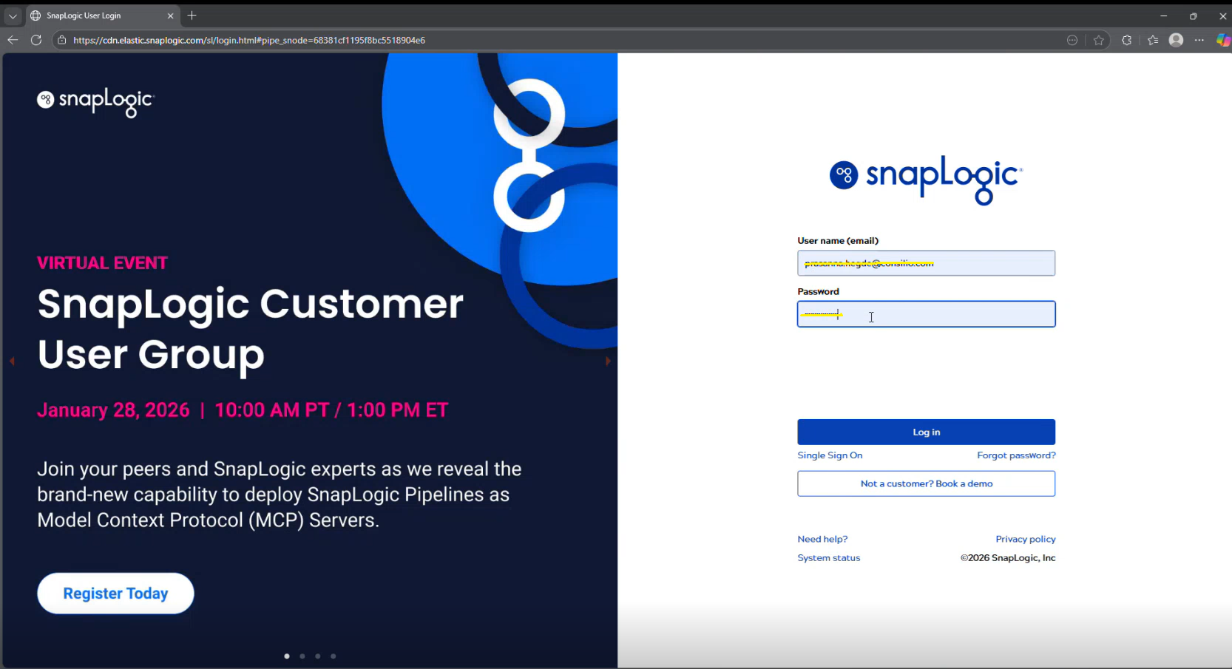
5. If an active session exists, SnapLogic may skip the login page and open the dashboard directly.

3. SnapLogic Interface Overview

SnapLogic provides three main modules that are used during development and monitoring activities:

3.1 Designer
The Designer is the workspace where pipelines are built. It allows developers to place snaps, connect them, configure their settings, and view the output after each snap during validation. This is where the actual implementation logic is created using the snaps available in SnapLogic.

3.2 Manager
The Manager contains all components required for a project, including pipelines, accounts, configuration files, and tasks. Items that are not visible in the Designer—such as service accounts, environment-specific configuration files, and project level assets—are stored here. This module provides a complete view of everything associated with a project.

3.3 Monitor
The Monitor provides visibility into all pipeline executions, including the number of runs, execution duration, and execution status (success or failure). It includes both scheduled executions and manually triggered runs.
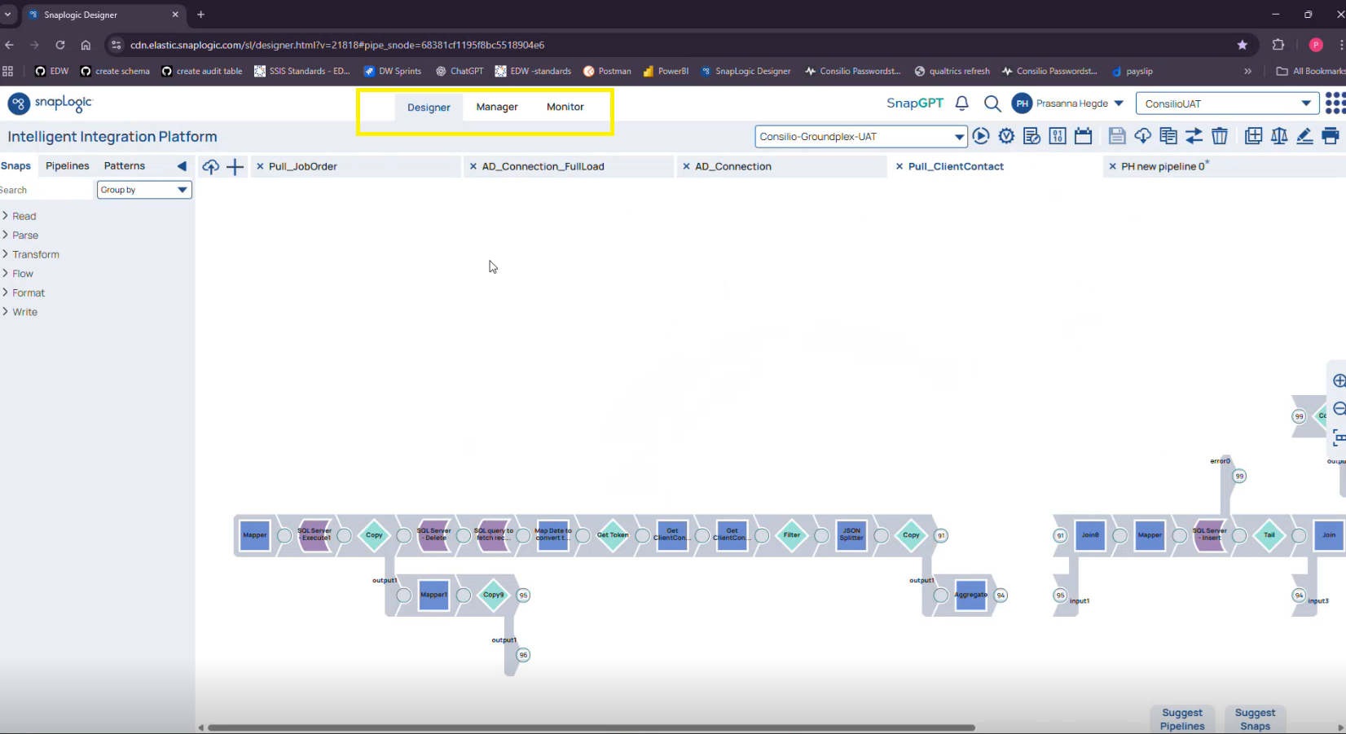

4. Snaps, Pipelines, and Patterns

4.1 Snaps
Snaps are individual components used to construct a pipeline. Each snap performs a specific action—such as calling an API, mapping fields, splitting JSON, or inserting data into a database. The logic inside each snap is pre-built, and developers configure the required fields. Multiple snaps are connected together to form the workflow. All detailed information about SnapLogic Snaps, including configuration properties and usage details, is available in the Info section of the SnapLogic documentation: https://docs.snaplogic.com/snaps/snaps-core/sp-api-suite/http-client.html

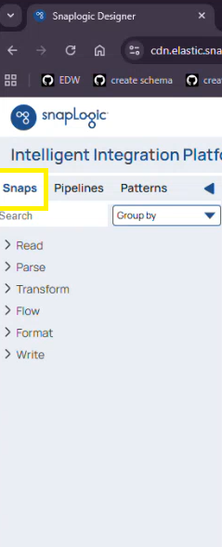

4.2 Pipelines
A pipeline is a complete workflow created by connecting snaps. It defines the full process required to extract, transform, and load data. Pipelines are stored within projects and can be executed manually or through scheduled tasks.

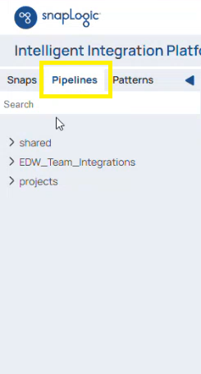

4.3 Patterns
Patterns are reusable templates visible within the Designer. These appear alongside snaps and pipelines and provide pre-built structures that help maintain consistency when multiple pipelines follow similar logic.
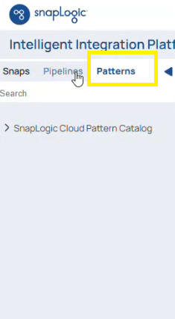

5. Pipeline Setup

The steps below describe the full process for creating a new pipeline in SnapLogic—from preparing the project to adding snaps, configuring accounts, and validating execution.

5.1. Preparing the Project Structure

A pipeline must be created inside a project. If a suitable project does not already exist, create one using the following steps:
- Navigate to the Manager tab.
- Open the relevant parent folder (for example, the integrations folder used for EDW).
- Select Create Project from the dropdown. A Create Project window appears; do the following:
• Project name – Enter the name of the project where all related pipelines, accounts, tasks, and configuration files will be stored.
• Make this a pattern project checkbox– Select this if the project is intended to store reusable templates or reference pipeline structures.
• Disable cloud URL checkbox– A system-controlled option that remains unavailable by default and does not require any changes for standard use.
Pipeline Validation – This section controls whether pipelines created in this project can be validated.
- Inherit from Org settings – An option under Pipeline Validation that uses the default validation behavior defined at the organization level.
- Enabled – An option under Pipeline Validation that allows developers to run validation and preview snap output.
- Disabled – An option under Pipeline Validation that disables validation for all pipelines in this project.

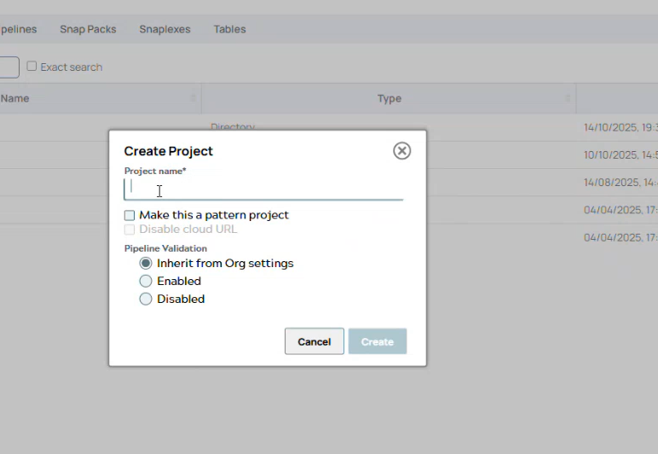

5.2 Creating a Pipeline

- In the SnapLogic interface, navigate to Designer → Pipelines to view all pipelines available within the selected project.
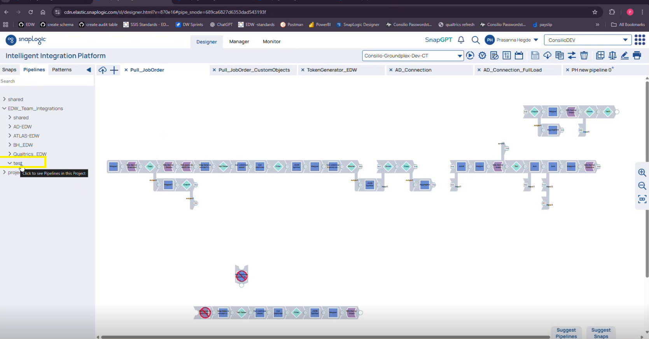
- Click the (+) icon to open the pipeline creation window.

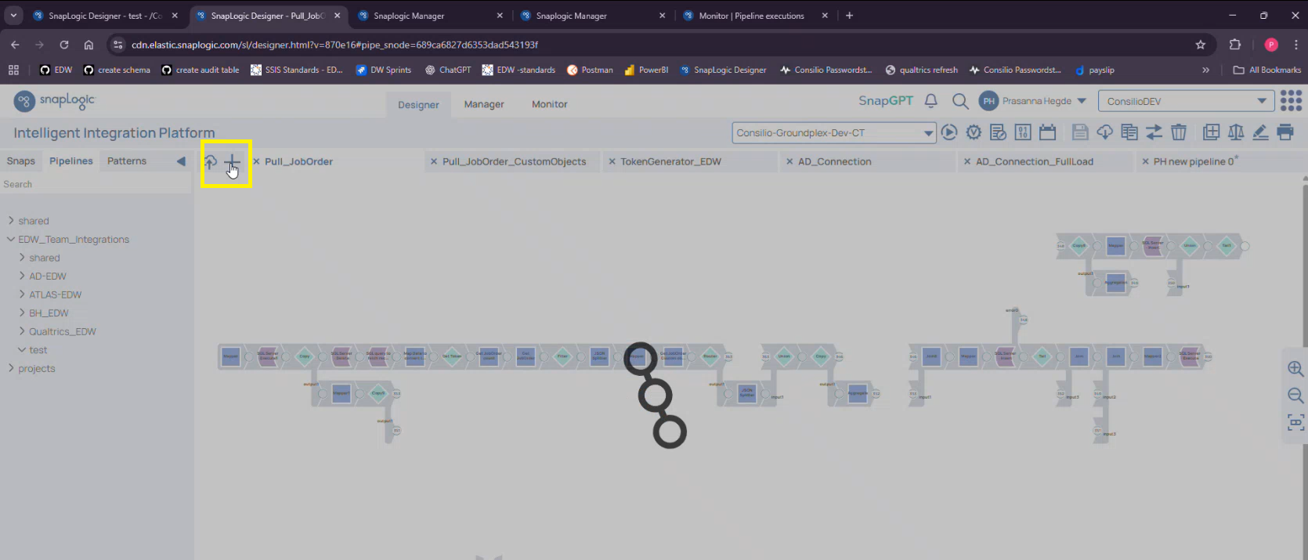
- Enter a Pipeline Name that clearly represents the purpose of the pipeline.
- From the dropdown list, select the Project under which the pipeline should be stored and use the Parameters section to add key–value pairs for any dynamic inputs the pipeline will require (such as page numbers, limits, schema names, or environment-dependent values). These parameters allow the pipeline to use dynamic values rather than hard-coded inputs.
- Error Pipeline Parameters
This section is used to define parameters that are applied specifically when the pipeline sends records to an error pipeline. These parameters function the same way as standard pipeline parameters but are dedicated to error handling paths. In the Add New Pipeline window, you can add the required key–value pairs for error related configuration.
- Expression Libraries
This section is used to attach external expression (configuration) files to the pipeline. These files typically contain environment specific values such as URLs, service accounts, or other reusable variables. When adding a new pipeline, you can attach the required expression file and assign it an alias.

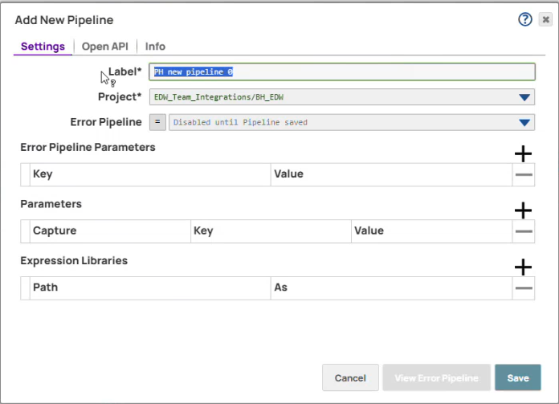

- Click Save, after which a new pipeline opens on a blank designer canvas where snaps can be added and configured.

8. After the pipeline is created, the Edit Pipeline window allows you to modify parameters, enable the Capture checkbox for parameters or error parameters, and update or change the expression library and its alias as needed.
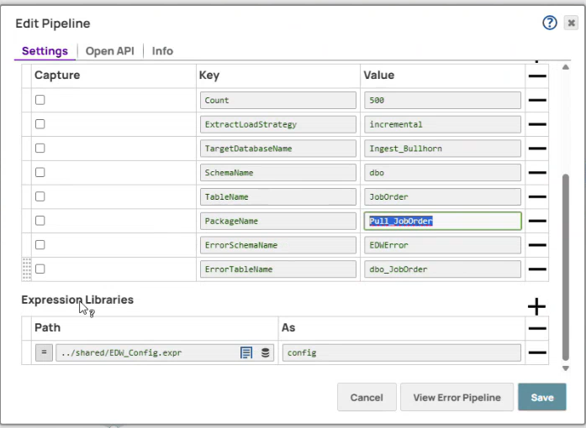

6. Building the Pipeline – Detailed Steps

When a pipeline is being built in SnapLogic, the workflow is constructed by placing snaps onto the canvas and connecting them in the sequence required to complete the process.
Snap is the individual functional unit (the “box”) that performs a specific task within the pipeline, and the complete workflow is created by chaining multiple snaps together to achieve the end-to-end outcome.
Snaps contain prebuilt internal logic, so building a pipeline involves selecting the appropriate snaps and configuring their available settings based on the requirement.
SnapLogic provides different categories of snaps—such as Read, Parse, Transform, Flow, and Format—which cover all stages of a typical ETL process.
- Read snaps bring data into the pipeline, such as retrieving records from an API or system.
- Parse snaps interpret or break down incoming data structures so they can be processed further.
- Transform snaps reshape, map, or modify the data into the required structure before loading.
- Flow snaps control how data moves through the pipeline, for example routing, branching, or sequencing records.
- Format snaps convert data into the appropriate output format before loading or passing it downstream.

When working in Designer, the Info tab can be used to view details about what each snap does, and the Validation tab allows you to preview how data flows through each snap during development.

7. Demo Pipeline creation

A demo pipeline is created below to show how SnapLogic retrieves data from the Atlas API, processes the response through each snap, and loads the final output into the ingest table.

7.1 HTTP Client (POST) – Generate Token

Purpose:
Generates a session token required for authentication with the API. This is typically the first snap in the pipeline, as the token is needed for all subsequent API calls.

Method: The Request method field can be set to any HTTP method supported by the endpoint (such as GET, POST, PUT, or DELETE). In this pipeline, POST is selected because the endpoint requires a session token to be generated through a login request, and this authentication call must be made using a POST method to submit the necessary credentials.
Use of Configuration Expression Library (POST)
Before configuring this Snap, the required configuration file is attached to the pipeline under Expression Libraries. The file is selected from the project directory and assigned an alias (such as config). This alias is then referenced inside the POST Snap to retrieve environment specific values such as the session generation URL, login name, password, and any other reusable variables needed for the authentication request.

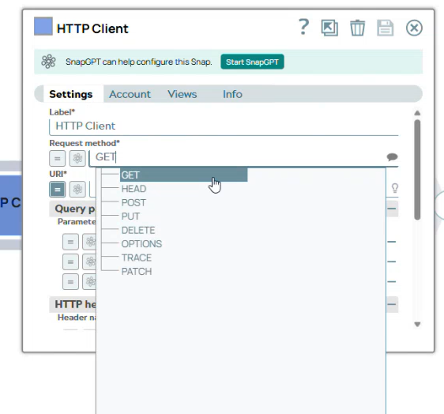

URL: Retrieved dynamically from the expression library (session URL for the current environment).
Query Parameters:
Login name – service account username stored in the configuration file
Password – encrypted service account password also stored in the configuration file
HTTP headers
The HTTP headers section displays header-level options such as Enable debug, Use form encoding for spaces, and Prevent URL encoding, and any of these options may be selected if the specific API you are calling requires them.
HTTP entity
The HTTP entity section is used to specify the request body that will be sent with the HTTP call, and this is where the payload is captured if the endpoint requires body content; if the API does not require a body, this section remains empty.
Pagination
Pagination is applied because the API can return a large number of records, and retrieving everything in a single request is not practical; instead, the API is designed to return results in smaller batches across multiple pages.

In this setup, the request uses page to indicate which batch to fetch and per_page to control how many records are returned in each batch, and the pipeline iterates through pages until all records are retrieved.
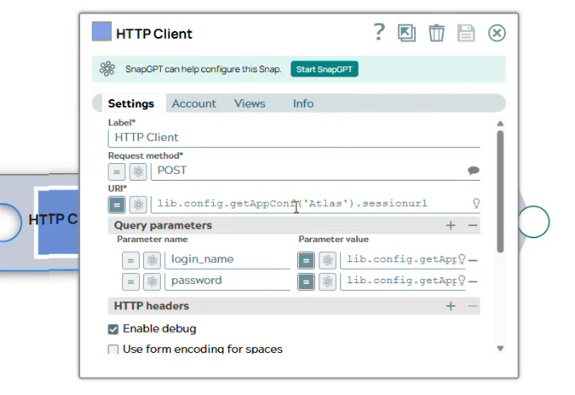

7.2 Mapper Snap – Extract and Store Token

Purpose:
Immediately after the authentication HTTP Client Snap, a Mapper Snap is added to capture the session token returned in the POST response. This snap extracts the token from the API response payload and stores it in a pipeline variable (for example, token), allowing downstream snaps—especially the next HTTP Client snap—to reuse it for authentication.
The Mapper ensures that only the required value (the token) is isolated and stored, keeping the pipeline clean, efficient, and reusable.

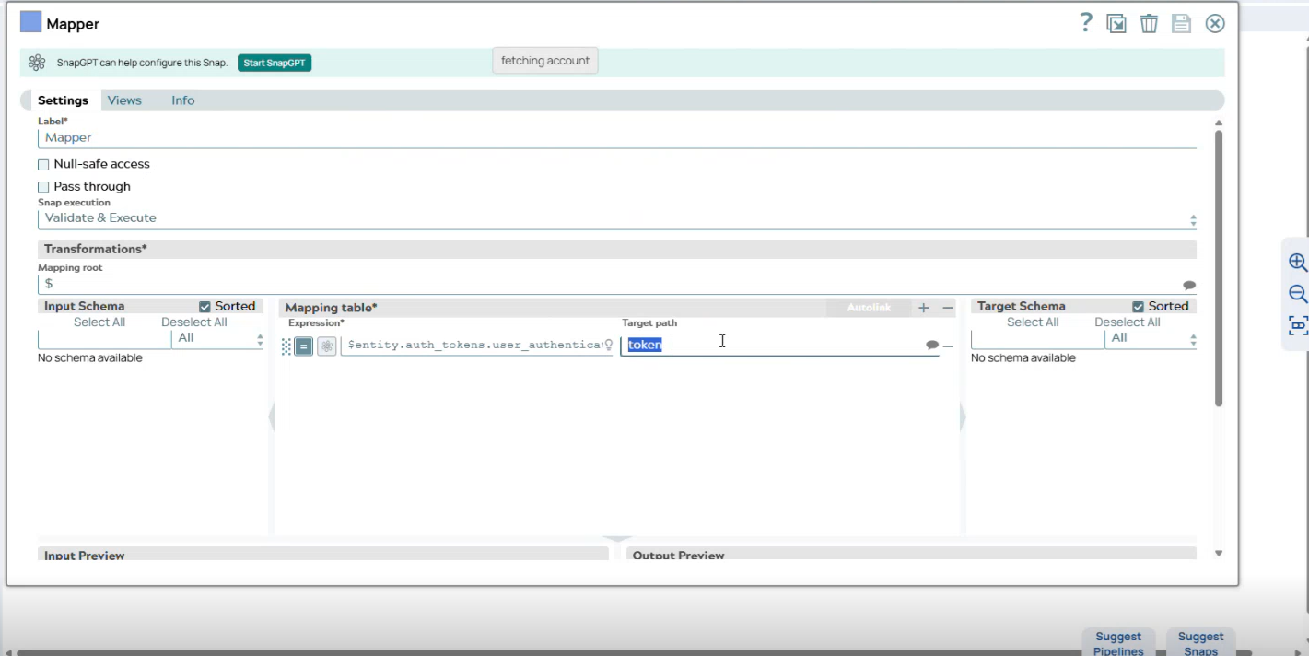
7.3 HTTP Client (GET) – Fetch Data
Purpose:
This Snap is configured as a GET request used to retrieve paginated data from the target API. All environment specific values—such as the endpoint URL, authentication details, and parameter values—are sourced dynamically through configuration files and pipeline parameters to ensure reusability and flexibility across environments.
Use of Configuration Expression Library:
Before configuring this Snap, the required configuration file is attached to the pipeline under Expression Libraries. The file is selected from the project directory and assigned an alias (such as config). This alias is then referenced inside the GET Snap to retrieve environment specific values like the API URL, user credentials, and any other reusable variables.

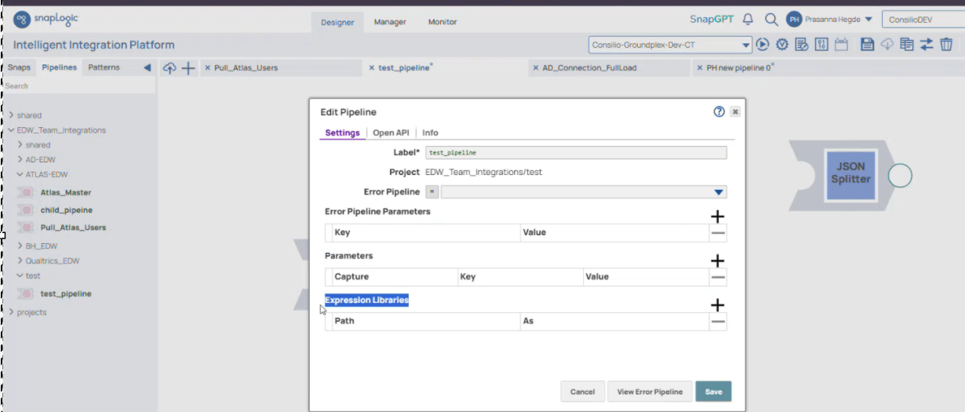

URL:
Retrieved dynamically from the configuration expression library using the assigned alias. No value is hardcoded, ensuring that the correct environment-specific endpoint is always used.
Headers:
Includes the authentication token that was extracted and stored by the previous Mapper snap. This ensures the GET request carries the required authorization.
Query Parameters:
Page – Specifies which page of results should be fetched.
Per_page – Defines how many records should be returned per page.

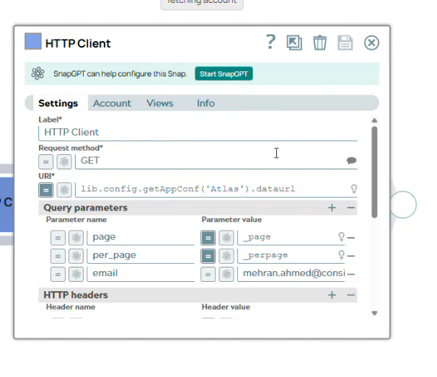

7.4 JSON Splitter – Extract User Records

Purpose:
The API response contains more information than required for processing. The JSON Splitter is configured to read data from the path entity.users, ensuring that only the list of user records is extracted. All other elements in the response, such as headers, status details, and debug information, are ignored.
After this Snap executes, each user record is split into an individual document, which allows the downstream Mapper and database load snaps to process each record independently.

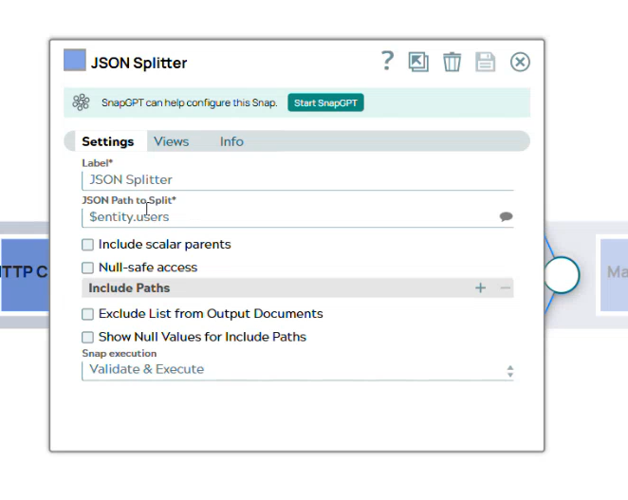

7.5 Mapper – Map Required Columns

Purpose:
The Mapper snap filters the API response to include only the specific fields required for insertion into the database. Although the API may return many attributes, only a subset is needed for the ingest table, and this snap extracts those necessary values and maps them to database friendly column names.
Mappings:
$.id → ID
$.name → Name
$.email → Email
(This list reflects the simplified demo mapping. The real pipeline may contain additional mappings.)
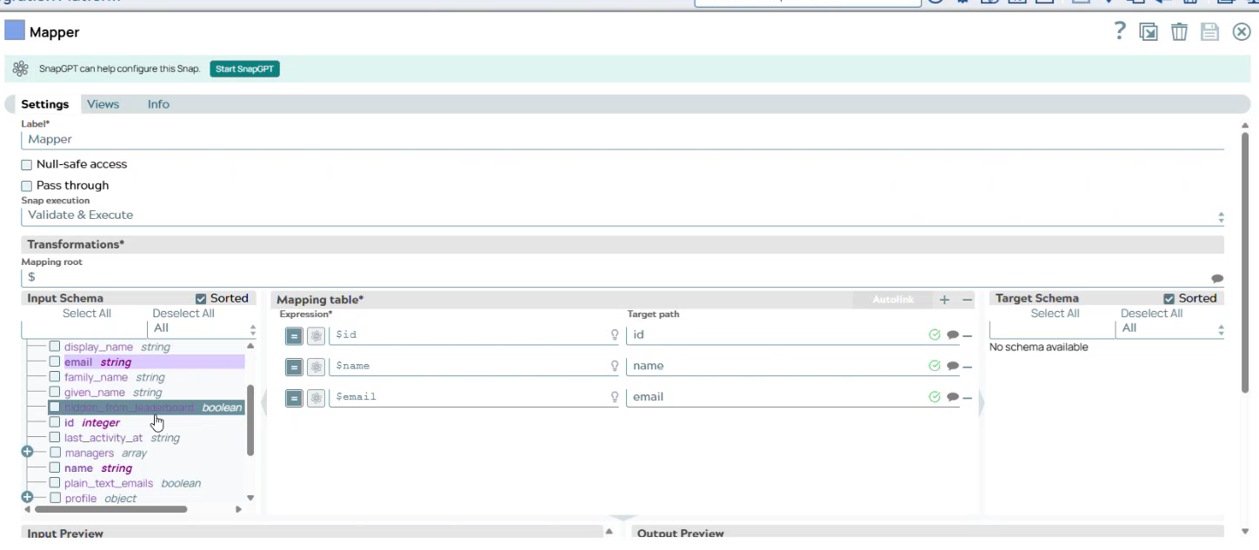

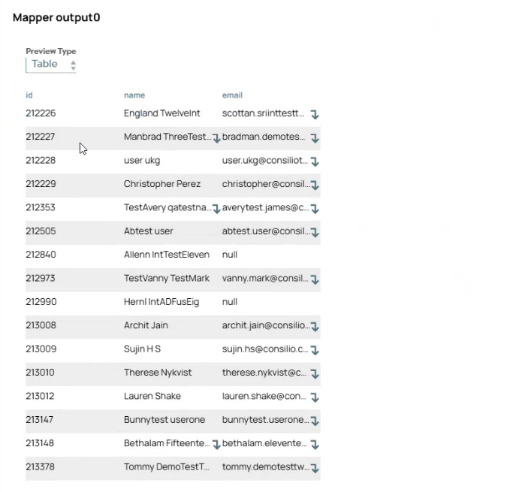

7.6 SQL Server Insert – Load Into Ingest

Purpose:
This Snap inserts the transformed user records into the ingest database table. It is the final step of the pipeline, after which downstream SSIS processes move the data into the Data Lake.
Configuration
- Account:
A valid Dev/UAT SQL Account is created at the project level and configured with the required connection details such as server name, database, username, and password. After creation, the account is validated to ensure the connection is successful before it is used in the SQL Insert Snap.
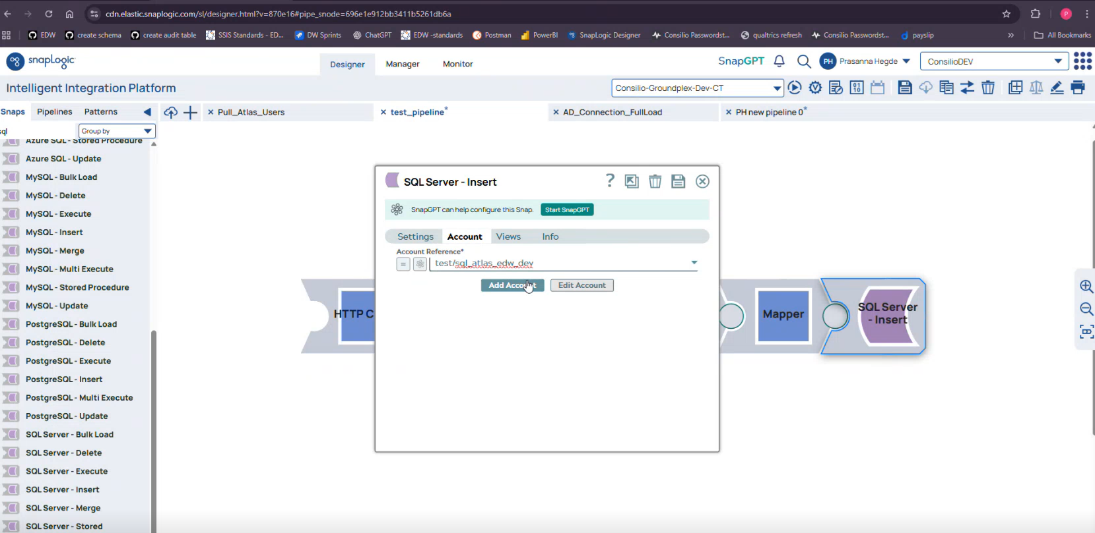
- Table:
users_test
This table was created in the database specifically for the demo to illustrate how the SQL Insert snap loads processed user records.
In real-time projects, the target ingest table is pre-defined and created by the EDW/Database team as part of the data model. Developers simply reference the existing table in the Insert snap.

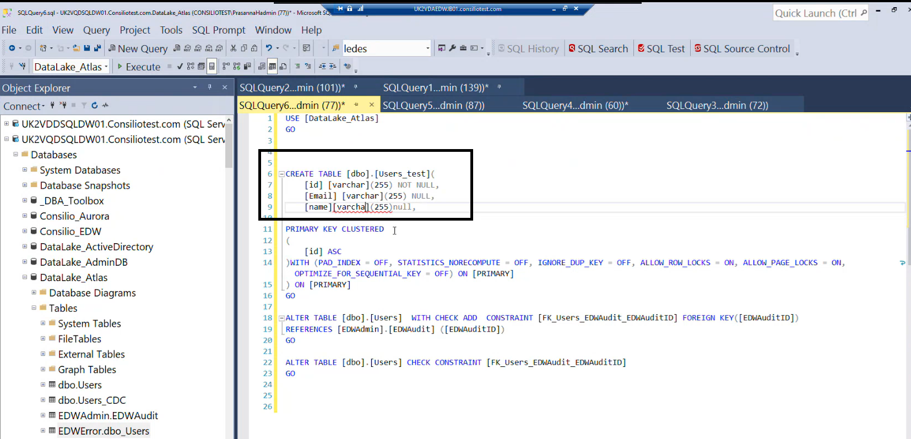

In the Settings tab of the SQL Server – Insert snap, the Schema name is entered (for example, dbo) and the Table name is specified (for example, users_test) to define the target insert location. As these values are provided, SnapLogic validates them against the configured SQL account and indicates successful resolution when the fields are recognized. Optional settings such as Create table if not present, retry parameters, and Enable identity insert are configured only when required. The Snap execution option is then selected based on whether validation should run before executing the insert.
- Execution Type Options:
  - Validate & Execute – Runs validation and performs the full insert.
  - Execute Only – Skips validation and directly loads the data.
  - Disabled – Disables only this snap, not the entire pipeline.

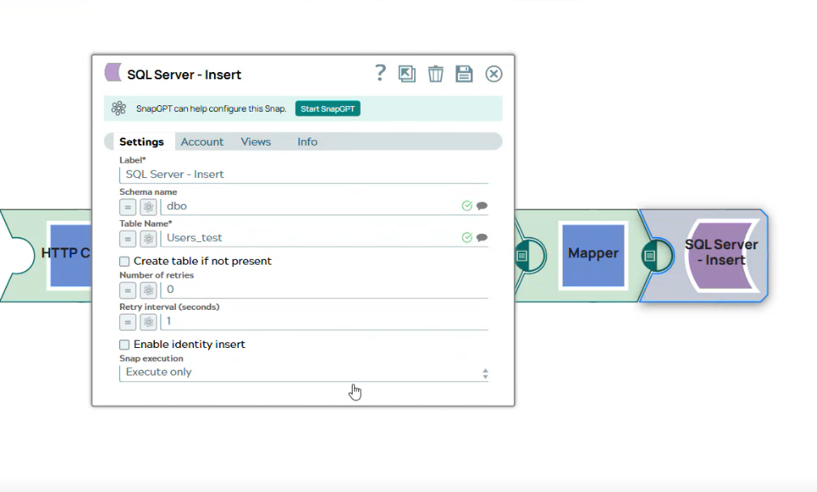

7.7 Validating & Executing the Pipeline

Once all snaps are configured, the pipeline must be validated and executed to ensure it runs successfully end-to-end.
Validate
- The Validate option runs the pipeline in preview mode.
- Each snap displays sample output so developers can confirm that the configuration, mappings, and data flow are correct before running the full load.
- This stage helps identify issues such as missing parameters, incorrect paths, invalid accounts, or API failures without inserting any records into the database.
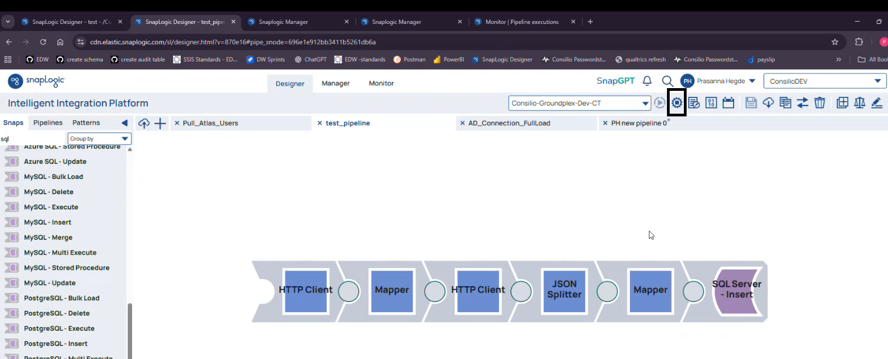
Execute
- The Execute option performs the actual end-to-end run of the pipeline.
- All snaps execute fully, API calls are made with live data, and the processed records are inserted into the target ingest table.
- Developers can track execution progress in real time using the execution logs.
Statistics
After the pipeline finishes execution, the Statistics tab becomes available. It provides execution level performance and diagnostic details, including:
- CPU usage
- Memory usage
- Total runtime
- Error details, if any failures occurred
This information helps verify performance and troubleshoot bottlenecks or snap level failures.

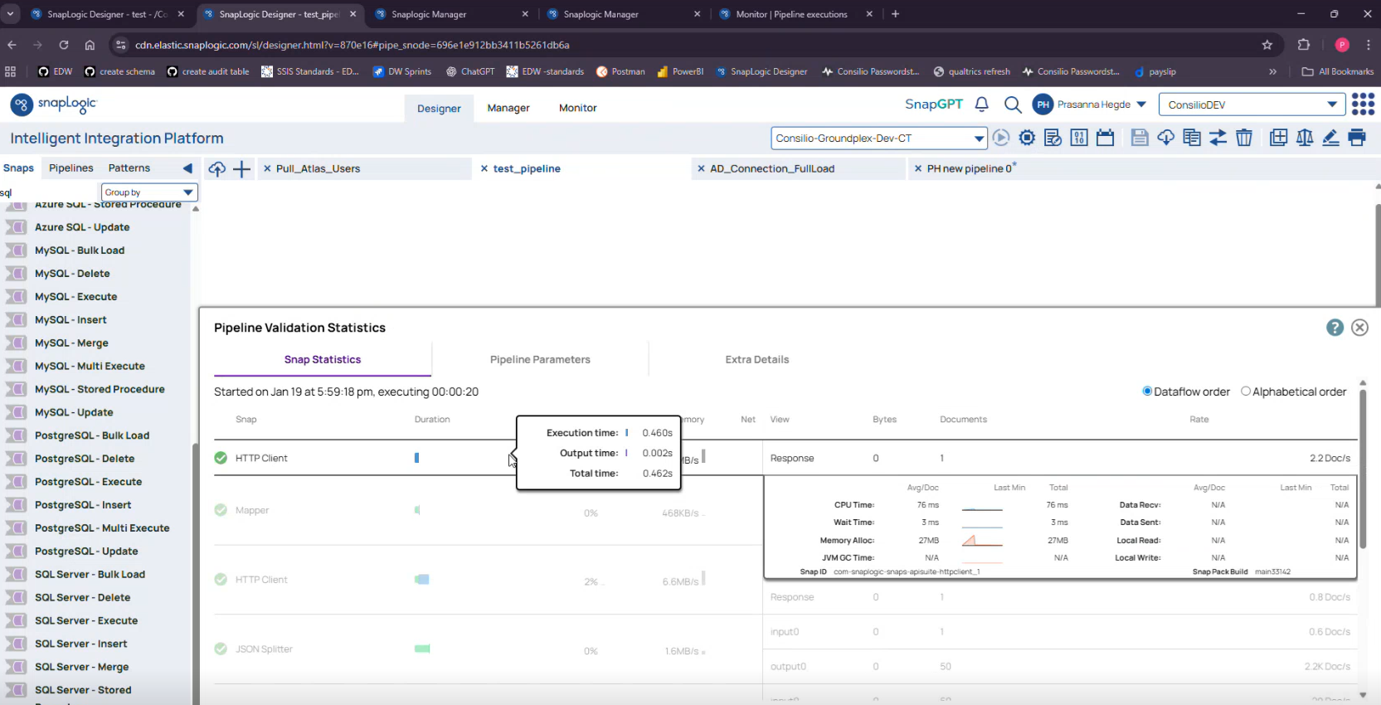

7.8 Database Validation

Database validation is an optional verification step used to confirm that the pipeline load successfully inserted records into the target ingest table. This step is typically performed after execution to ensure that data is present in the expected schema and table.
When to perform this step
Perform this validation after the pipeline execution (especially after the SQL Server Insert snap runs) to confirm that:
- The table is accessible.
- Rows are being inserted.
- The inserted data looks correct.

8. Scheduling the Pipeline (Task Creation) — Detailed SOP Section

Tasks are used to automate pipeline execution so the pipeline runs on a defined schedule (for example, daily). Pipeline scheduling ensures that the pipeline runs automatically at a defined frequency and maintains a record of each run’s execution details, including success, failure, and runtime statistics.

8.1 Navigate to Tasks

1. Open SnapLogic → Manager.
2. Go to Tasks to view existing scheduled runs and create new ones.
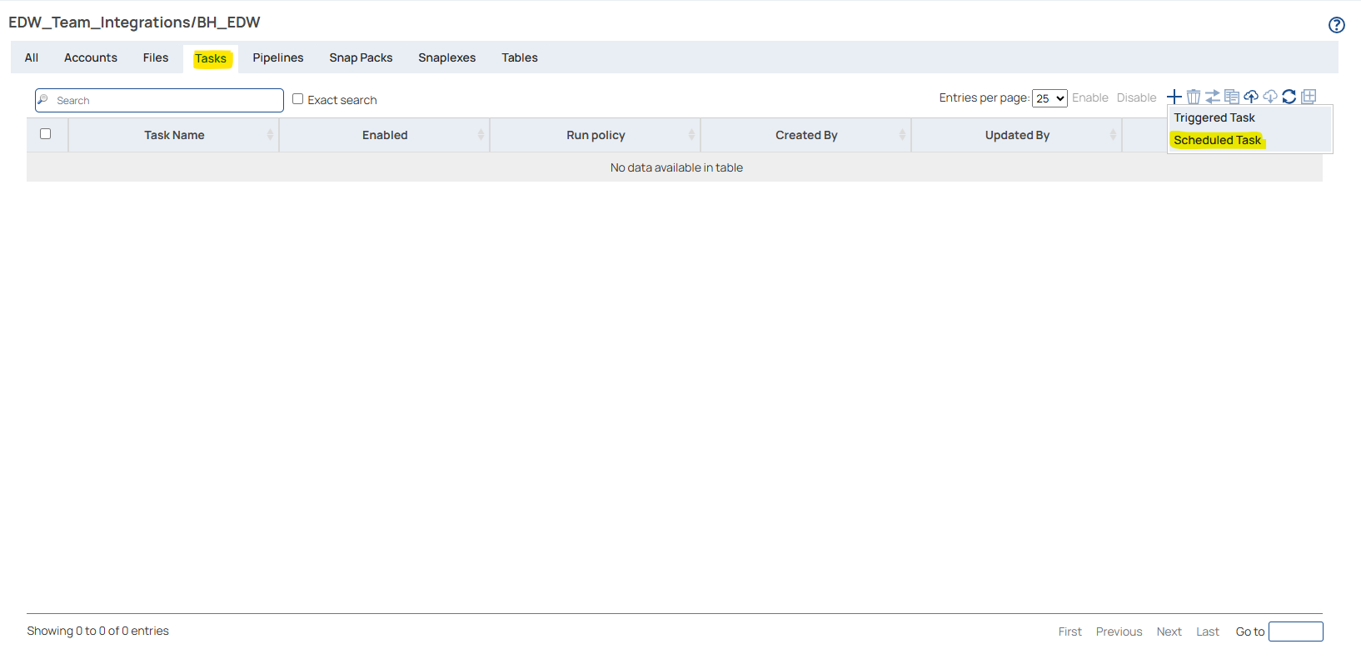

8.2 Create a new Pipeline Task

1. Select Create Task.
2. Provide a Task name that clearly identifies what the schedule is for.
3. Select the Pipeline that must run on the schedule (the session shows selecting the pipeline to run under the task configuration).
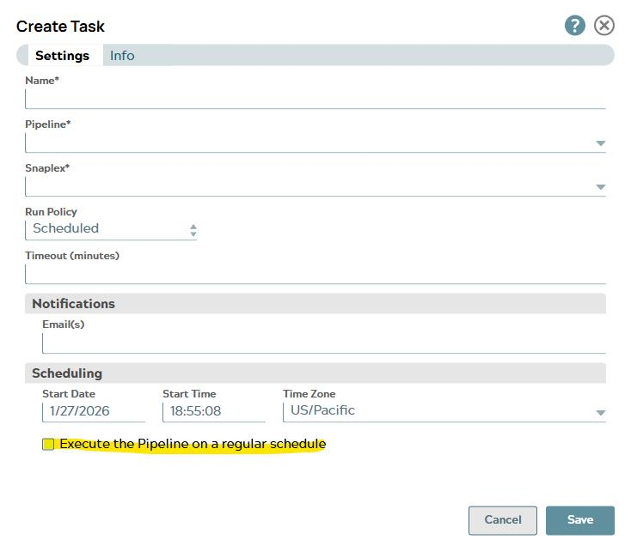

8.3 Configure the schedule (frequency and time)
1. Set the task to run daily (the session describes the pipeline running every day using the task).
2. Configure the run time as needed.

8.4 Configure notifications
1. Enable email notifications so failures are visible to the support group.
2. Configure email notifications so that, if the scheduled task fails, an alert is automatically sent to the designated support or distribution group.

8.5 Additional Scheduling Controls
After configuring email notifications, select Execute the Pipeline on a regular schedule.
This opens the scheduling prompt where the task frequency and timing can be configured.

In this window, enable the option Do not start a new execution if one is already active.
This prevents overlapping runs—meaning if a current execution is still in progress when the next scheduled time arrives, SnapLogic will not trigger another execution. This ensures:
- long running loads do not overlap,
- data is not duplicated or partially loaded,
- the system avoids unnecessary resource contention.

8.6 Save and monitor scheduled runs

1. Save the task configuration.
2. Use Monitor to review each scheduled execution (runtime, success/failure, and run history are described as part of monitoring scheduled tasks).

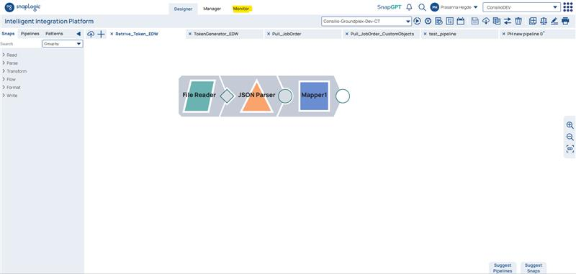
3. Select the project you want to monitor; this filters the execution history to only that project's pipelines.

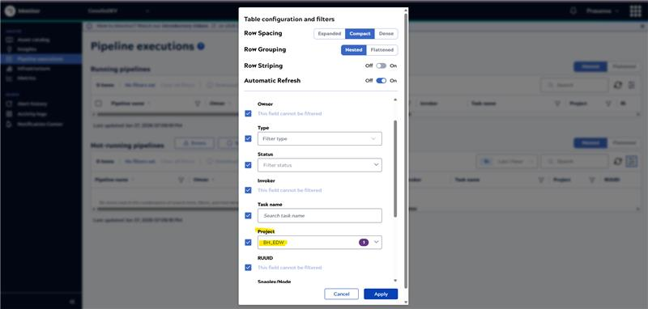

4. If you select a specific timestamp window, SnapLogic will display all pipeline executions from that project that occurred within the selected timeframe.
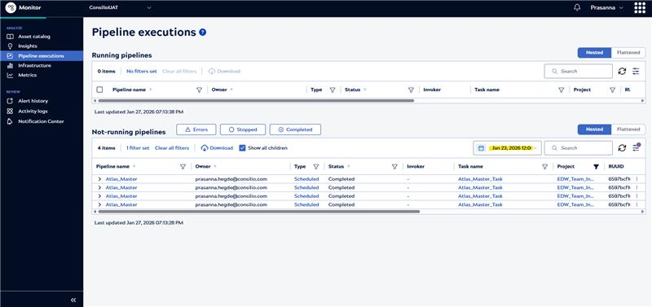

9. Error Handling & Troubleshooting

This section outlines the most common issues encountered during pipeline development and execution, along with the reasons they occur and how each issue should be resolved. These errors typically surface during validation, execution, or API interaction stages.

1. HTTP Client (GET) Call Failures – Common Causes
HTTP Client (GET) calls may fail due to missing request parameters, authentication issues, or network related errors. Common causes include the following:
Missing Pagination Parameters (page / per_page)
This issue occurs when the HTTP Client (GET) Snap does not receive required pagination parameters such as page or per_page. SnapLogic expects these parameters to be provided either through pipeline parameters or expression library variables. If they are missing, the API cannot determine which page of data to return or how many records to include per request, resulting in a failure.
Expired Token
If the authentication token used in the request has expired, the API rejects the request and returns an authorization error. This typically occurs when tokens are not refreshed before their expiry window.
Invalid or Incorrect Credentials
Incorrect client credentials, API keys, or authorization headers cause authentication failures, preventing the GET request from being processed successfully.
Gateway Timeout (504)
A 504 Gateway Timeout error occurs when the API server does not respond within the expected time frame. This may be caused by network latency, high server load, or long running requests.
How to Resolve
- Ensure page and per page parameters are defined in the Pipeline Parameters section and correctly referenced in the HTTP Client Snap.
- Re-validate the pipeline to confirm that all required parameters are passed during execution.
- Verify that authentication tokens are valid and refreshed as required.
- Confirm that credentials and authorization details configured in the Snap are correct.
- For timeout errors, review API performance, reduce payload size if possible, or retry the request based on API guidelines.

2. Token Missing → Unauthorized Error
The token-based authentication flow requires that the session token generated by the first HTTP Client (POST) snap be captured correctly and passed to all downstream calls.
If the Mapper snap after the POST call does not extract and store the token, or if the token variable is referenced incorrectly in the GET snap, the API rejects the request and returns an Unauthorized (401) error.
How to Resolve:
- Verify that the Mapper snap extracts the token (e.g., $.entity.token) and stores it in a variable.
- Confirm that the GET snap includes this token in the Headers section under the correct parameter.
- Re-run validation to ensure the token is flowing correctly between snaps.

3. Table Not Found → Invalid Schema/Table
This error occurs during the SQL Server Insert snap when SnapLogic cannot locate the target database table.
This typically happens due to:
- Incorrect schema name
- Incorrect table name
- A mismatch between environment-specific tables
- Missing permissions in the SQL account
SnapLogic flags the field with a red indicator when the table cannot be resolved.
How to Resolve:
- Confirm the schema (e.g., dbo) and table name are correctly entered in the Insert snap.
- Confirm that the ingest table already exists in the target database.
- Validate the SQL account used in the project to ensure connectivity and permissions.
4. Account Not Referenced → SQL Snap Fails
SQL-based snaps must reference a valid SQL Server Account created at the project level.
If the account is not attached—or if the attached account is invalid—the SQL Insert snap cannot establish a connection to the database, causing the snap to fail during validation or execution.

How to Resolve:
- Ensure a valid SQL account exists under the project’s Accounts section.
- Attach this account to the SQL Insert snap under the Account dropdown.
- Validate the connection within the account settings before re-running the pipeline.

